Windows Servers & Installation

Daily Task 1

Basic of Windows Server and AD

- Install Windows Server on a virtual machine using VirtualBox or VMware and take a screenshot of the desktop after the installation completes. ➢
  - Open the virtualization software.
  - Create a new virtual machine.
  - Allocate RAM and create a virtual hard disk.
  - Attach the Windows Server 2019 ISO file.
  - Start the virtual machine and begin the installation.
  - Select the Windows Server edition and complete the installation.
  - Restart the virtual machine after installation.
  - Log in using the Administrator account.
  - Verify that the Windows Server desktop opens successfully.
Screenshots :
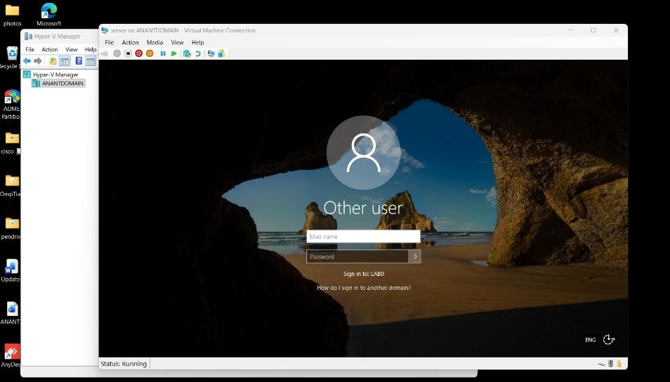
Windows Server 2019 Log in screen After Successful Installation.
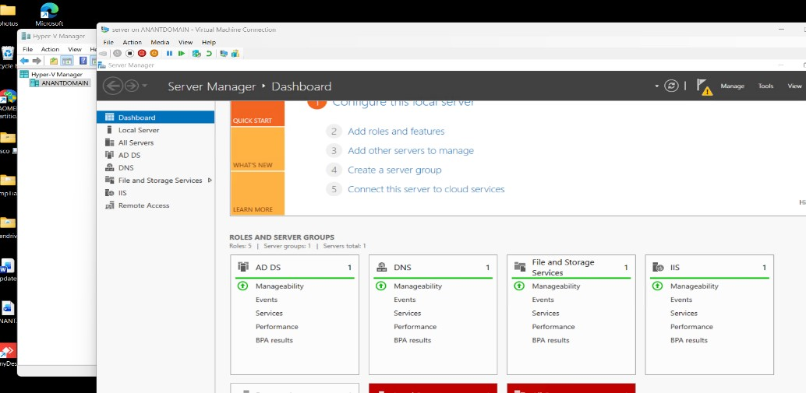
Windows Server 2019 Virtual Machine Running in Hyper-V.

- Open Server Manager and use the 'Add roles and features' wizard to install the Active Directory Domain Services (AD DS) role. Document each step with a short description and screenshot. ➢
Step 1: Open Server Manager
Log in to Windows Server and open Server Manager. It is used to manage server roles, features, and configurations.
Step 2: Select Add Roles and Features
Click Manage and select Add Roles and Features to start the installation wizard.
Step 3: Before You Begin
Read the introductory information and click Next.
Step 4: Select Installation Type
Choose Role-based or feature-based installation and click Next.
Step 5: Select Destination Server
Select the local server from the server pool and click Next.
Step 6: Select Server Role
Check Active Directory Domain Services (AD DS) in the Server Roles list.
Step 7: Add Required Features
When prompted, click Add Features to include the required supporting features, then click Next.
Step 8: Select Features
Keep the default selections unless additional features are required, then click Next.
Step 9: AD DS Information
Read the information about Active Directory Domain Services and click Next.
Step 10: Confirm Installation
Review the selected roles and features, then click Install.
Step 11: Verify Installation
Wait for the installation to complete and verify that Active Directory Domain Services is installed successfully
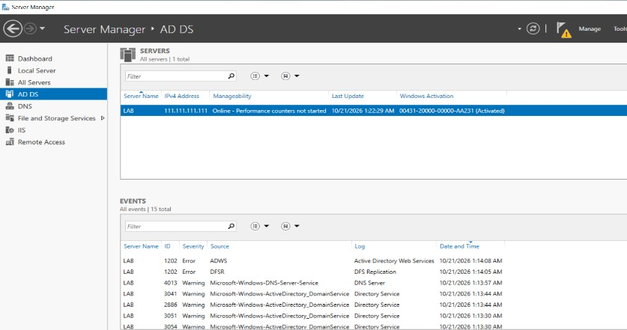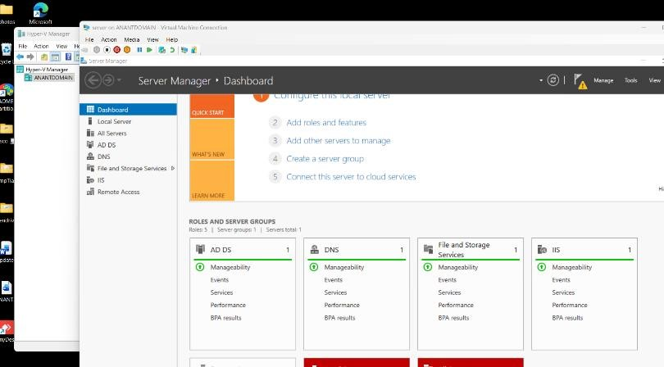

- Promote your Windows Server to a Domain Controller by creating a new forest with a root domain name of your choice (e.g., mycollege.local). List the options you selected during the configuration. ➢
  - Open Server Manager.
  - Click the notification flag and select Promote this server to a domain controller.
  - In Deployment Configuration, select Add a new forest.
  - Enter anant.local as the root domain name.
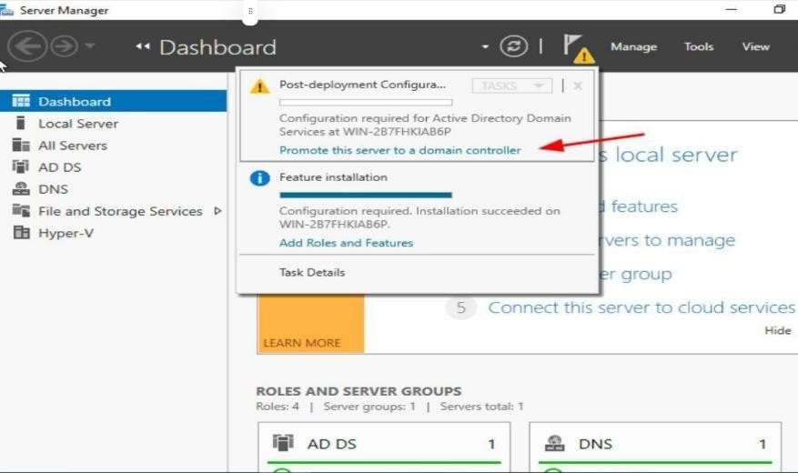
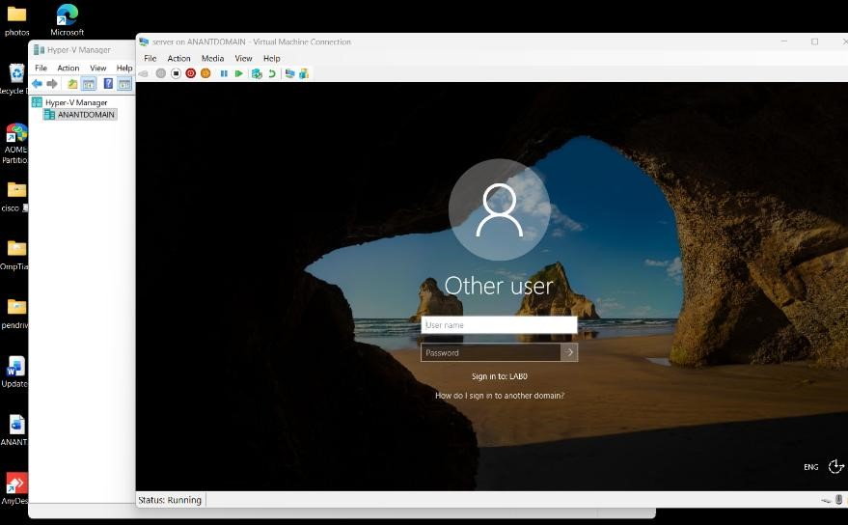
  - On the Domain Controller Options page, select the appropriate forest and domain functional levels supported by the server.
  - Keep Domain Name System (DNS) server and Global Catalog (GC) selected.
  - Enter and confirm the Directory Services Restore Mode (DSRM) password.
  - Review the DNS Options page and proceed.
  - Verify the NetBIOS domain name, usually ANANT.
  - Keep the default paths for the Active Directory database, log files, and SYSVOL unless a different location is required.
  - Review the configuration options and click Next.
  - Allow the prerequisite checks to complete. If no blocking errors are reported, click Install.
  - Wait for the server to restart automatically.
  - Log in using the domain Administrator account and verify that the server has become a Domain Controller.

- Create two new user accounts and one group in Active Directory Users and Computers. Assign both users to the group and describe how you did it.<br><br><em><strong>Hint:</strong> Use the 'Users' container and right-click options in ADUC.</em>
➢
Step 1: Open Active Directory Users and Computers
Open Server Manager, click Tools, and select Active Directory Users and Computers.
Step 2: Open the Users Container
Expand the domain anant.local and select the built-in Users container.
Step 3: Create the First User
Right-click the Users container, select New → User, and enter the user's name and logon name. Click Next, set a password, configure the password options, and click Finish.
Step 4: Create the Second User
Repeat the same procedure to create the second user account.
Step 5: Create a Group
Right-click the Users container, select New → Group, and enter the group name. Select Global as the group scope and Security as the group type, then click OK.
Step 6: Add Both Users to the Group
Right-click the newly created group and select Properties. Open the Members tab and click Add. Enter both user names, click Check Names, and then click OK.
Step 7: Verify Group Membership
Open the group's Properties and check the Members tab to confirm that both user accounts are listed.
